**Homework #1**

**CS 6810, Spring 2017**

**Problem 1:**

Consider the signal in equation (1):

s = (t0, 10), (t1, 8), (t2, 9), (t3, 5), (t4, 3), (t5, 3), (t6, 4), (t7, 6) (1)

In equation (1), the ﬁrst element in each pair, i.e., ti, 0 ≤ i ≤ 7, is a time point and the second element is the value of the signal sampled at that time. Write a formula for the step approximation function f for this signal and plot it.

**Answer:** If a signal or sample has n points, the formula for approximating step function is sum of all individual step function, i.e.

~f(r) = Sj·rj, rj+1r

From the problem statement above we can infer:

r0 = t0, r1 = t1, r2 = t2, r3 = t3, r4 = t4, r5 = t5, r6 = t6, r7 = t7

s0 = 10, s1 = 8, s2 = 9, s3 = 5, s4 = 3, s5 = 3, s6 = 4, s7 = 6

After putting the values, the step function equation becomes:

~f(r) = s0 r0, r1r + s1  r1, r2r + s2  r2, r3r + s3  r3, r4r + s4  r4, r5r + s5  r5, r6r + s6  r6, r7r + s7  r7, r8r

 10 rt0, rt1r + 8 rt1, rt2r + 9 rt2, rt3r + 5 rt3, rt4r + 3 rt4, rt5r + 3 rt5, rt6r + 4 rt6, rt7r + 6 rt7, rt8r

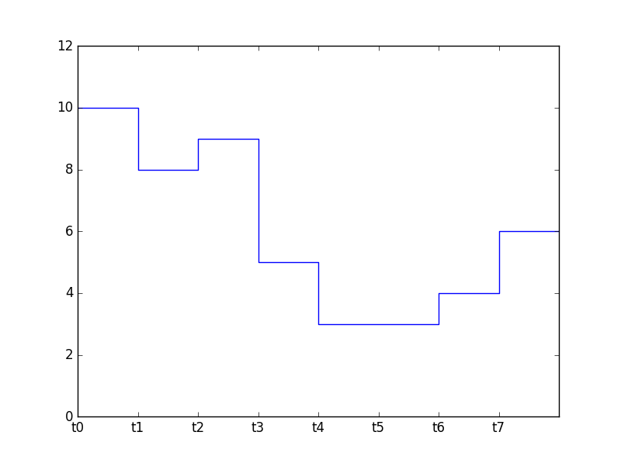

**Problem 2:**

This problem illustrates that the interval [0, 1[ is suﬃcient to express steps (and, consequently, wavelets) over arbitrary intervals. Try to show that the two formulas in equations (2) and (3) are correct for every number r. If you are not comfortable with formal proofs, you can use either algebraic manipulation or argue case by case.

φ[0,w[(r) = φ[0,1[(r/w) (2)

φ[u,w[(r) = φ[0,1[(r – u/w – u) (3)

**Answer:**

To verify:

ϕ[0, w[ (r) = ϕ[0,1[ (r/w)

If 0 ≤ r < w (Note: w > 0), that is 0 ≤ r/w < 1, makes ϕ[0, w[ = 1, then ϕ[0,1[ (r/w ) = 1;

otherwise, if r < 0 or r ≥ w, that is r/w < 0 or r/w ≥ 1, makes ϕ[0,w[ = 0, then ϕ[0,1[ ( r w ) = 0.

To sum up, we can see ϕ[0,w[ (r) = ϕ[0,1[ (r/w).

To verify:

ϕ[µ,w[ (r) = ϕ[0,1[ (r – u/w − u)

If u ≤ r < w, that is u − u ≤ r − u < w − u, makes ϕ[u,w[ (r) = 1, then we get 0 ≤ r − u < w − u, moreover 0 ≤ r−u/w−u < 1, so ϕ[0,1[ (r−u/w−u) = 1;

otherwise, if r < u or r ≥ w, that is r − u < 0 or r − u ≥ w − u, makes ϕ[u,w[ (r) = 0, then r−u/w−u < 0 or r−u/w−u ≥ 1, so ϕ[0,1[ ( r−u/w−u ) = 0.

To sum up, we can see ϕ[u,w [ (r) = ϕ[0,1[ (r−u/w−u).

**Problem 3:**

Compute the Basic HWT of the signal (8, 6, 7, 3, 1, 1, 2, 4)

**Answer:**

f = 8·ϕ[0, 1/8 [ + 6·ϕ[1/8, 1/4 [ + 7·ϕ[1/4, 3/8 [ + 3·ϕ[3/8, 1/2 [ + 1·ϕ[1/2, 5/8 [ + 1·ϕ[5/8, 3/4 [ + 2·ϕ[3/4, 7/8 [ + 4·ϕ[7/8, 1[

The basic transform applied to each pair gives:

8·ϕ[0, 1/8 [ + 6·ϕ[1/8, 1/4 [ = (8 + 6)/2 ϕ[0, 1/8 [ + (8 – 6)/2 ψ[1/8, 1/4 [ = 7 ϕ[0, 1/8 [ + 1ψ[1/8, 1/4 [

7·ϕ[1/4, 3/8 [ + 3·ϕ[3/8, 1/2 [ = (7 + 3)/2 ϕ[1/4, 3/8 [ + (7 – 3)/2 ψ[3/8, 1/2 [ = 5 ϕ[1/4, 3/8 [ + 2ψ[3/8, 1/2 [

1·ϕ[1/2, 5/8 [ + 1·ϕ[5/8, 3/4 [ = (1 + 1)/2 ϕ[1/2, 5/8 [ + (1 – 1)/2 ψ[5/8, 3/4 [ = 1ϕ[1/2, 5/8 [ + 0ψ[5/8, 3/4 [

2·ϕ[3/4, 7/8 [ + 4·ϕ[7/8, 1 [ = (2 + 4)/2 ϕ[3/4, 1 [ + (2 − 4)/2 ψ[3/4, 1[ = 3ϕ[3/4, 1 [ + (−1)ψ[3/4, 1 [

Thus,

~f = 7ϕ[0, 1/4 [ + 1ψ[0, 1/4 [ + 5ϕ[1/4, 1/2 [ + 2ψ[1/4, 1/2 [ + 1ϕ[1/2, 3/4 [ + 0ψ[1/2, 3/4 [ + 3ϕ[3/4, 1 [ + (−1)ψ[3/4, 1 [